## 

## **Practical-8**

**Student Name:** Gauri Prabhakar **UID:** 18BCS6201

**Branch:** 18AITAIML-2 **Section/Group:** B

**Semester:** 7 **Date of Performance:** 7th November, 2021

**Subject Name:** Computer Vision Lab **Subject Code:** CSF - 432

# Aim/Overview of the practical:

To implement face detection and mesh using mediapipe in python and OpenCV.

# Task to be done:

To implement face detection and mesh using mediapipe in python and OpenCV.

# Steps to be followed:

1. Importing necessary modules.
2. We will use 'drawing_utils' to draw the key points.
3. We will use 'face_mesh' to draw the mesh points.
4. Creating a variable to store the video using the '.VideoCapture()' function.
5. Specifying the detection and tracking confidence uisng 'mp_face_mesh.FaceMesh()'.
6. While the video is running.
7. Capturing the video frame by frame using the '.read()' method.
8. If there are empty frames.
9. If loading a video, use 'break' instead of 'continue'.
10. To improve performance, marking the video as not writable and passing by reference.
11. Reading the frames and converting them to RGB.
12. Detecting facess in the frame using the function 'face_mesh.process()'.
13. Drawing the face mesh annotations on the image.
14. Reading the frames and converting them to RGB.
15. If faces are detected that is 'results.multi_face_landmarks' returns true:
16. For 'face_landmarks' variable in 'results.multi_face_landmarks':
17. Connecting the key points using the function 'mp_drawing.draw_landmarks()'.
18. Face Mesh Tesselation.
19. Connecting the key points using the function 'mp_drawing.draw_landmarks()'.
20. Face Mesh Contours.
21. Rendering the video with effective face tracking to the console by using the function '.imshow()'.
22. Setting up '.waitkey()' to wait for a specific time until any key is pressed and break the loop.
23. '.waitkey(1)' displays a frame for 1ms after which it moves to the next frame in the video.
24. Setting 'x' as the quitting button.
25. Releasing the variable/object 'cap'.
26. **Result/Output/Writing Summary:**

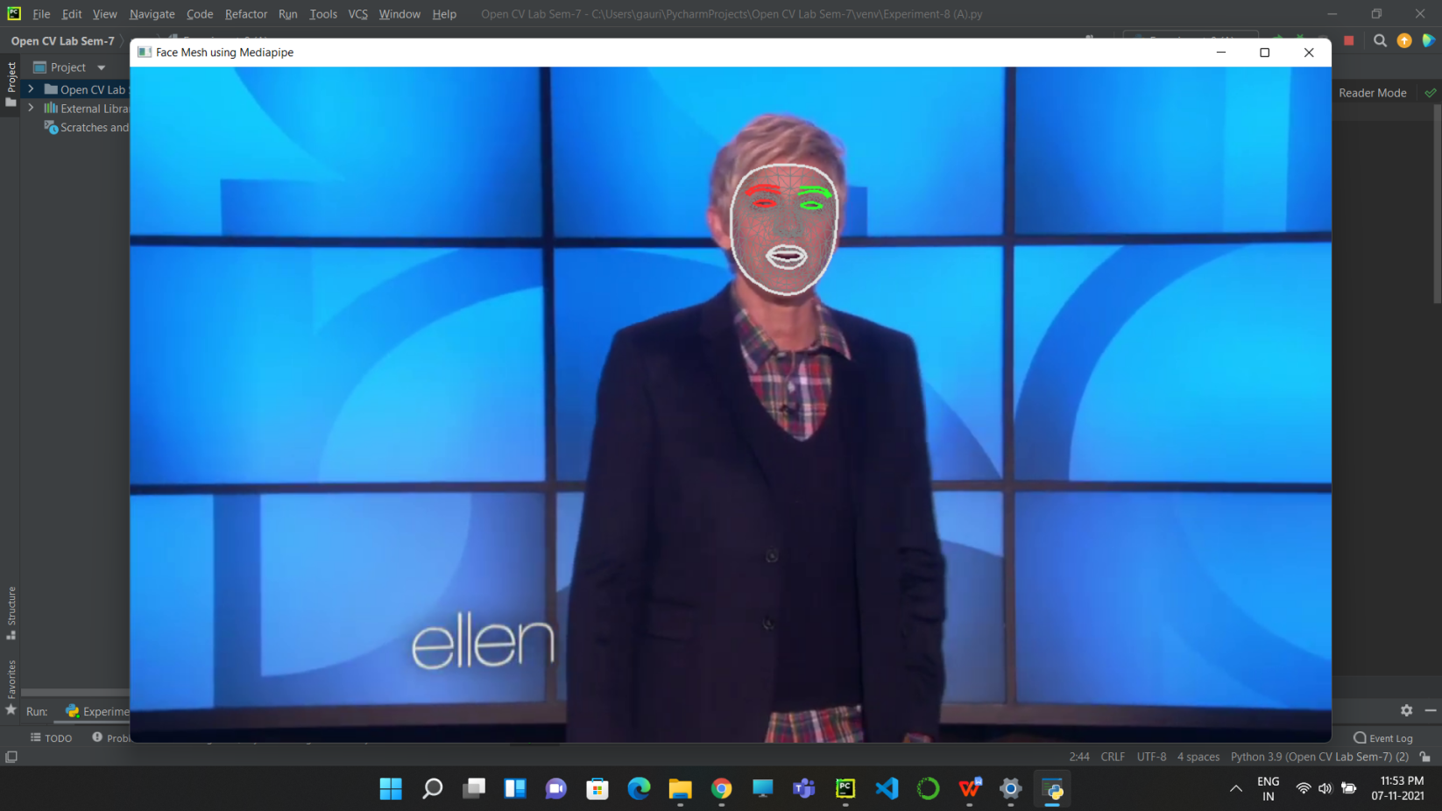

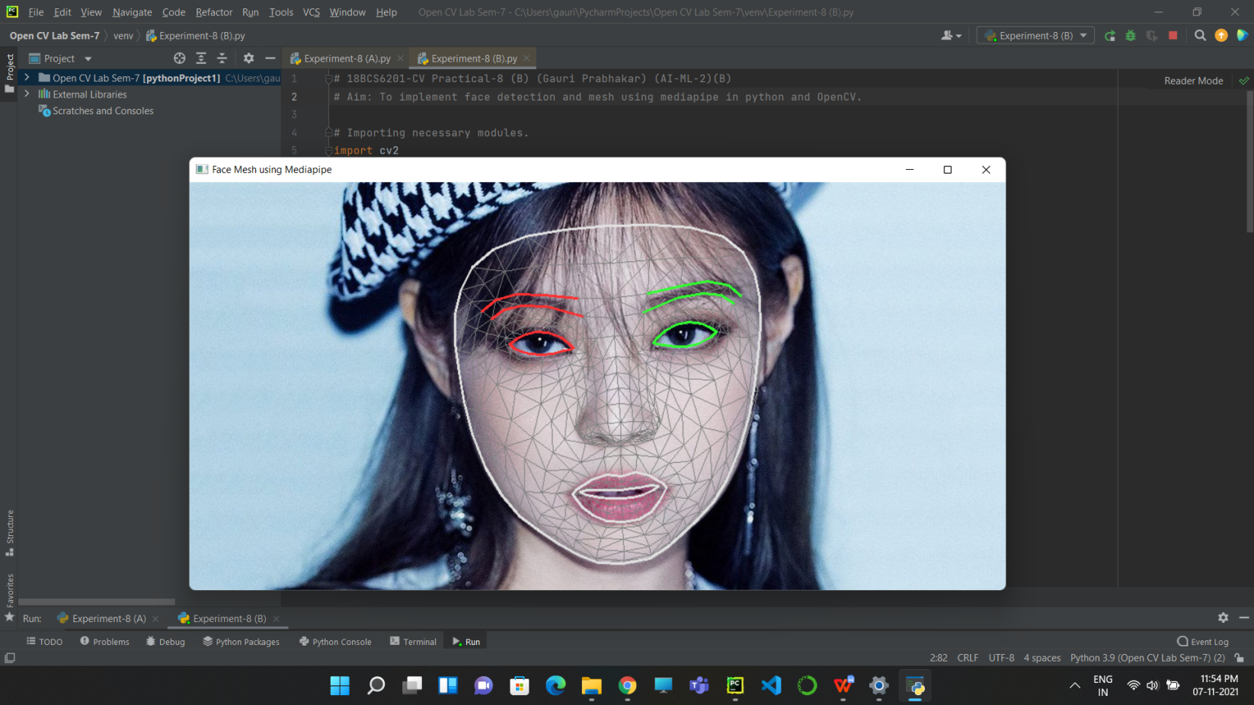

# Learning outcomes (What I have learnt):

* Open CV modules.
* The mediapipe library.
* Detect faces and displaying face mesh using the mediapipe library.
* Face tracking a saved video.
* Face tracking a saved image.
* Highlighting key points.
* Highlighting face mesh points.

**Evaluation Grid (To be created as per the SOP and Assessment guidelines by the faculty):**

|  |  |  |  |
| --- | --- | --- | --- |
| Sr. No. | Parameters | Marks Obtained | Maximum Marks |
| 1. |  |  |  |
| 2. |  |  |  |
| 3. |  |  |  |